APP Name : **Android Web View App**

* Home

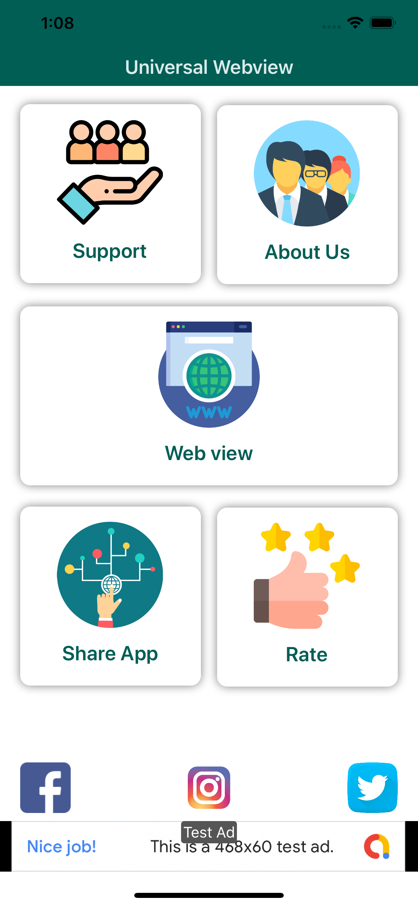

-> 8 Manu in Home

-> 1. Support Menu

-> 2. About Us

-> 3. Web View

-> 4. Share App

-> 5. Rate

-> 6. Facebook Page  
-> 7. Instagram Page

-> 8. Twitter Page

* Support Menu

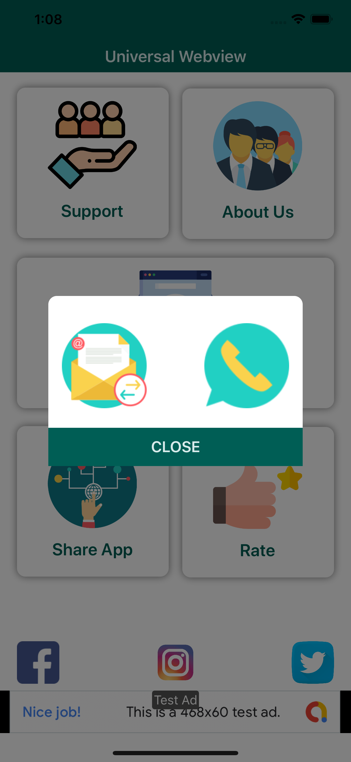

support Manu provide 2 type support

1) call support  
2) Email support

* About Menu

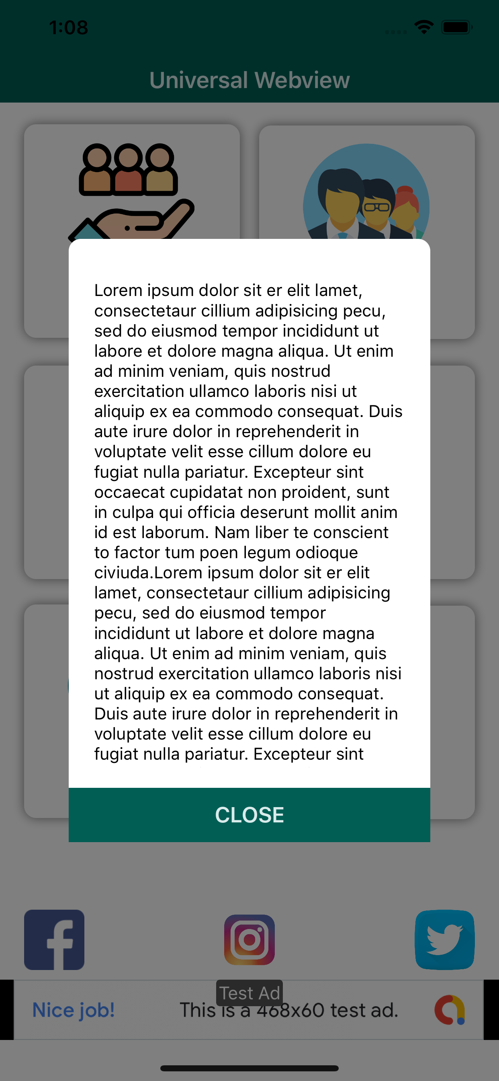

* Website open screen

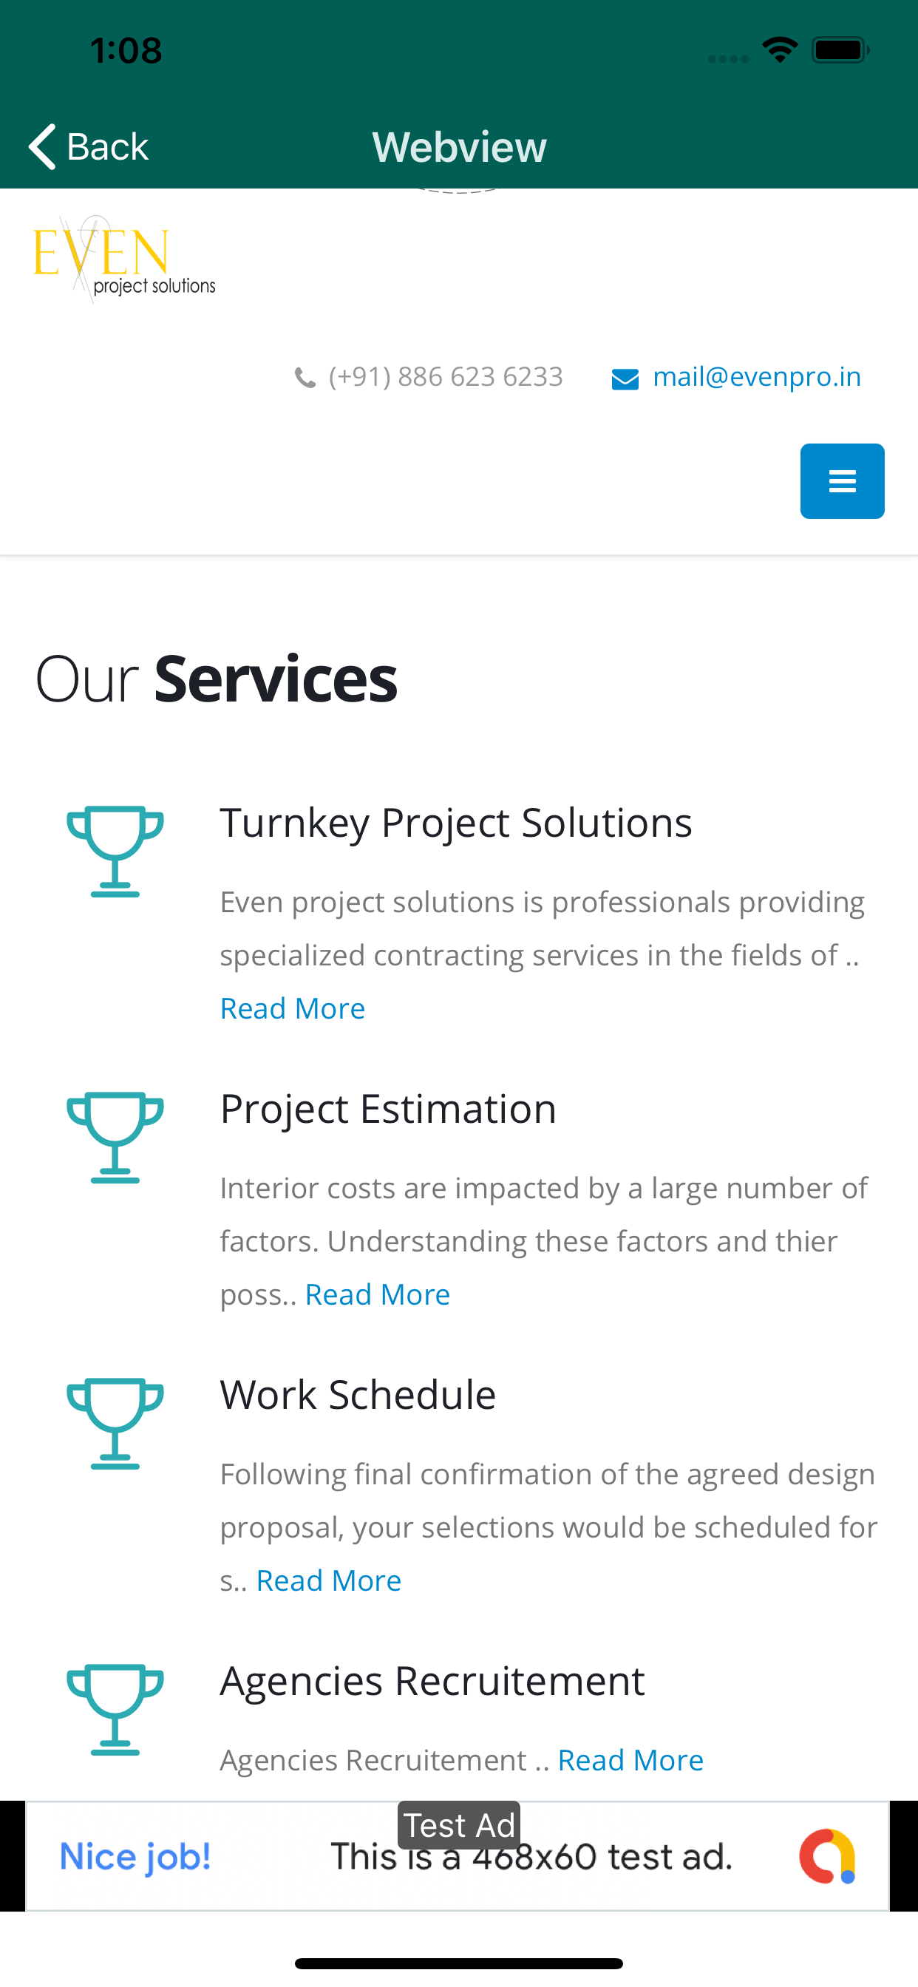

* Share app

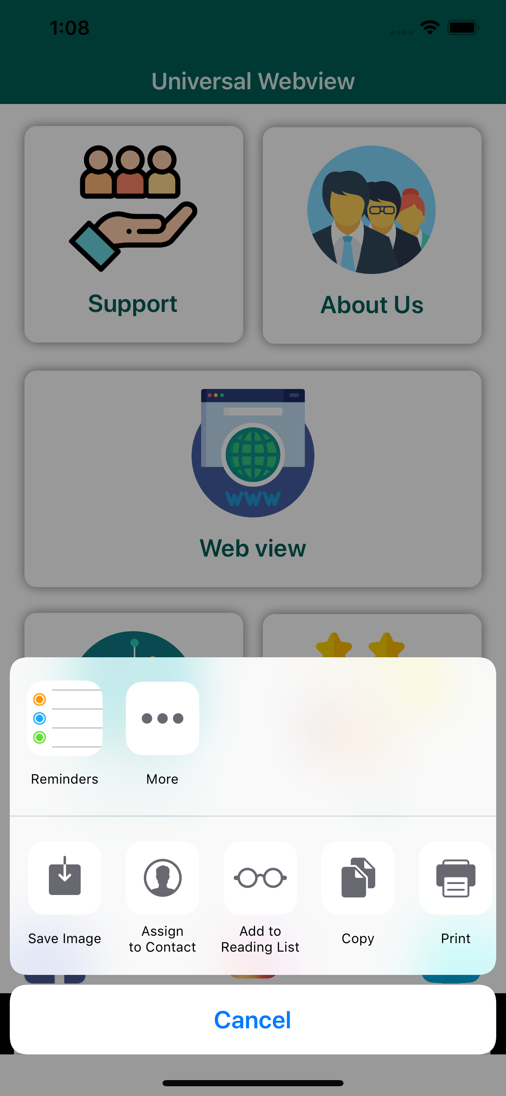

* Full screen ads

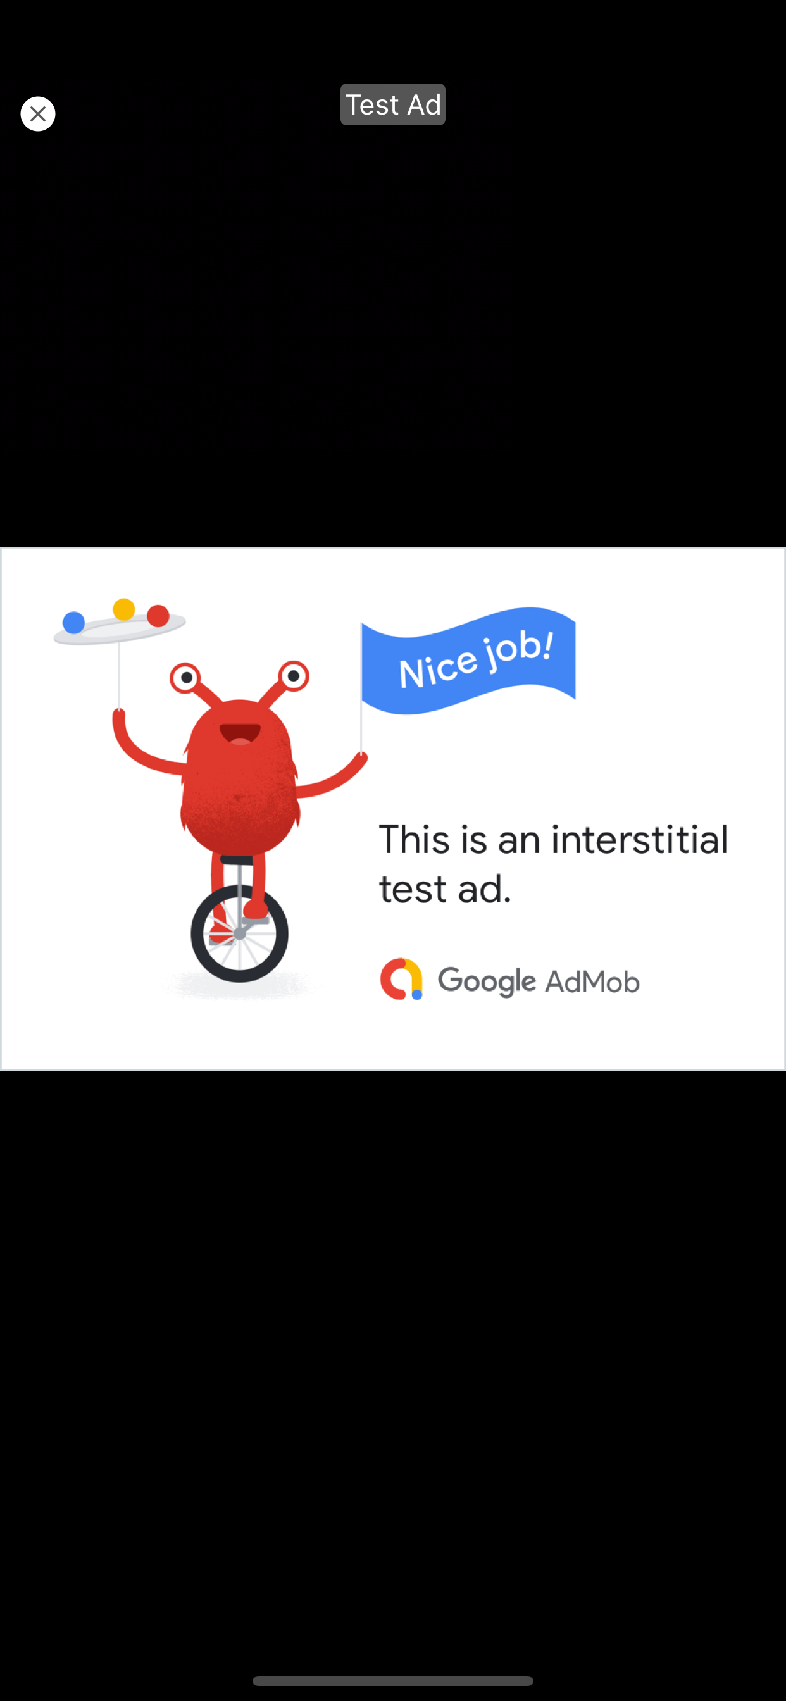

* Menu Screen

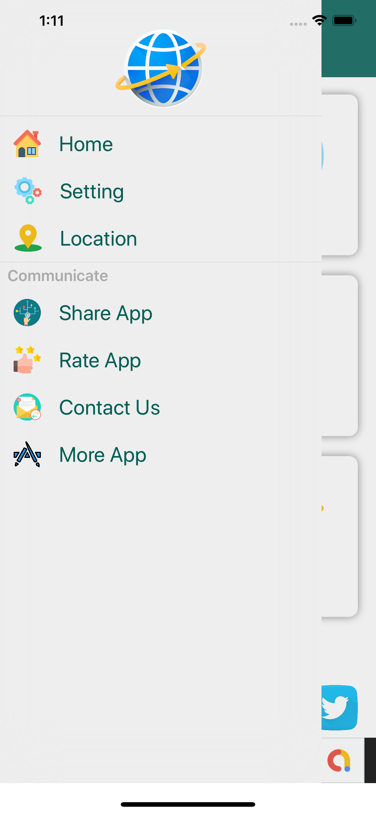

* Notification On/ Off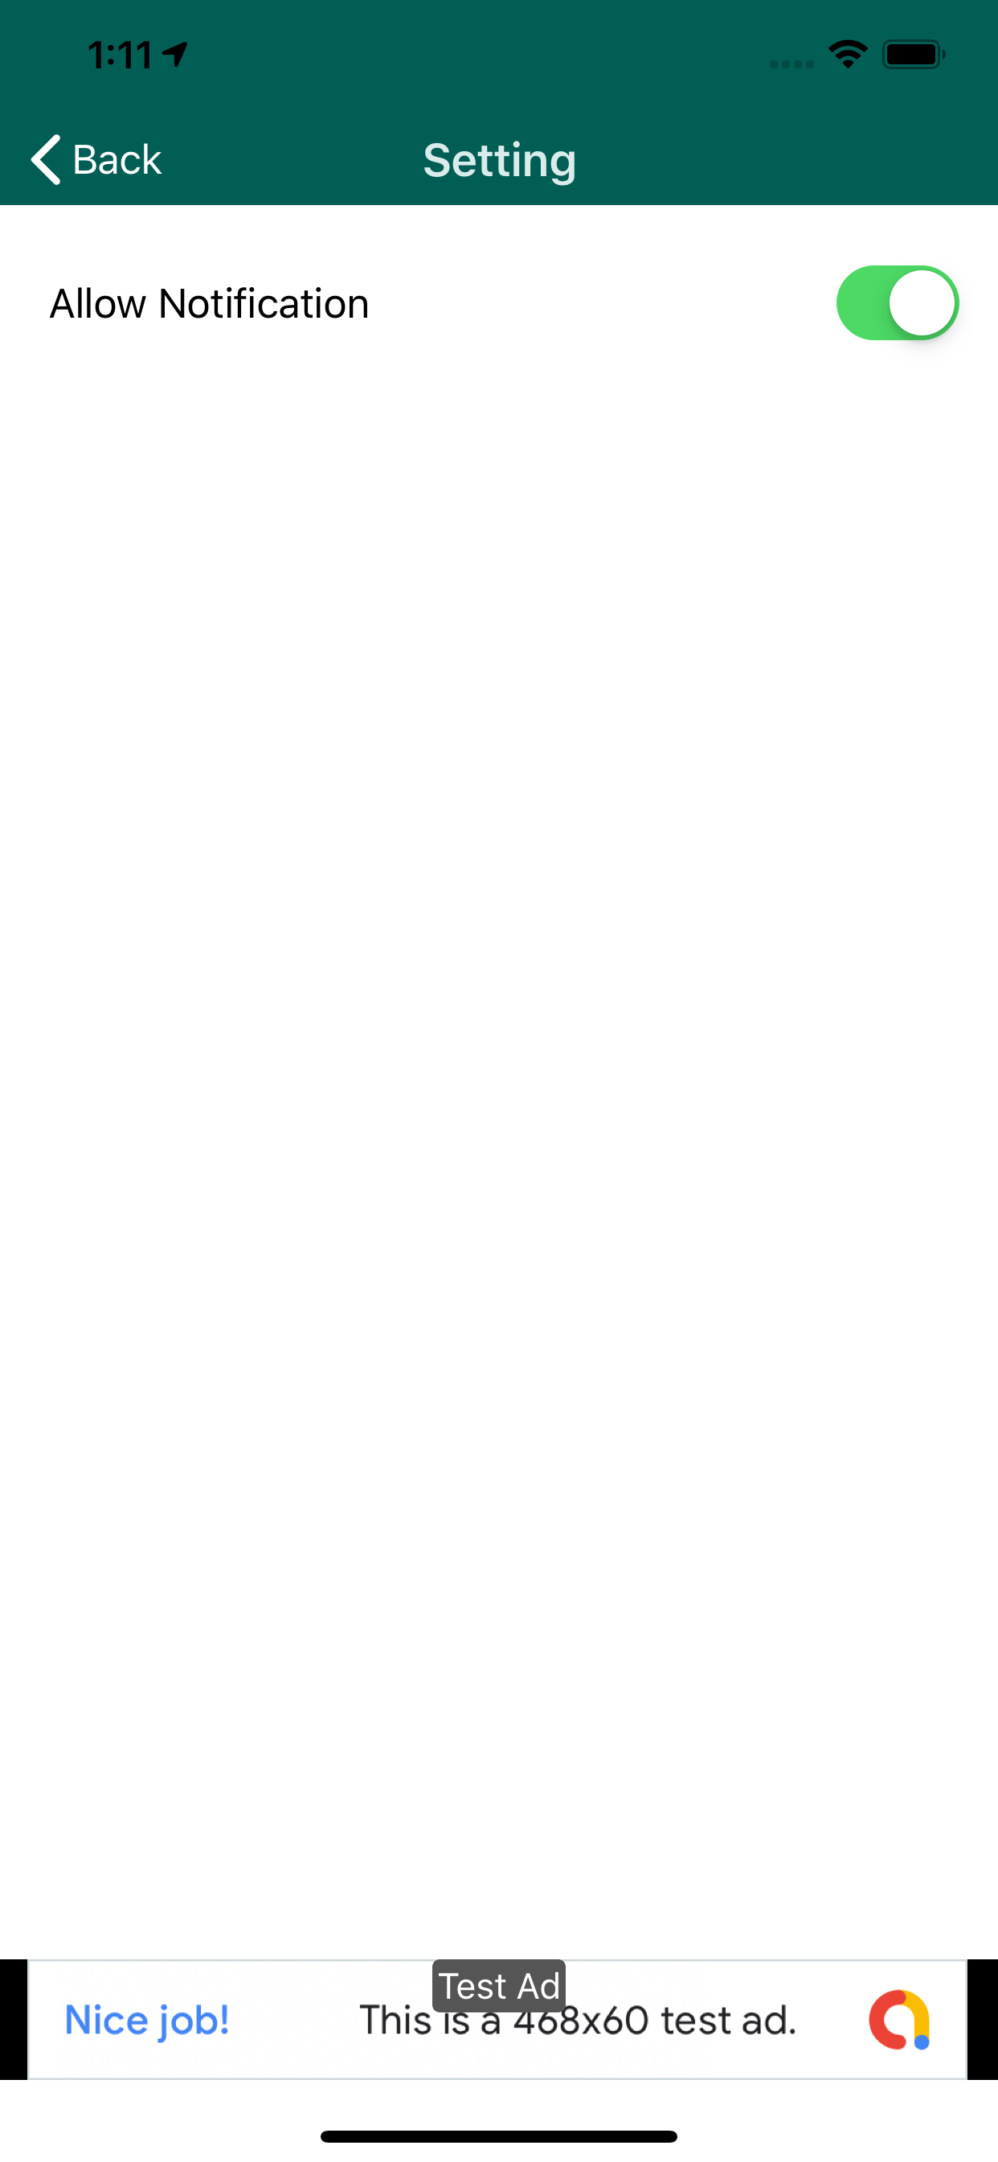
* Map Screen

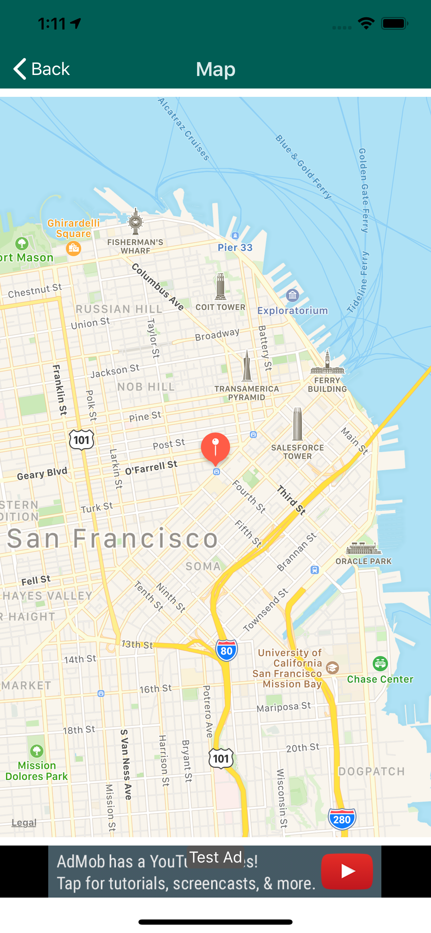

* Rate Screen

